
Pre-Surgery Instructions
https://fotasclinic.org/services/pre-surgery-instructions

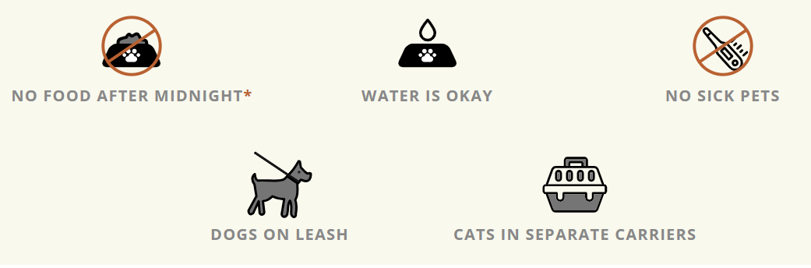
The night before
Food Restrictions
- Kittens and puppies UNDER 16 weeks old should be fed 2-4 hours before surgery. OR can be fed half of their usual breakfast. (Please follow these directions as they observe current medical best practices.)
- Cats and dogs OVER 16 weeks should receive no food after midnight. Skip any morning feedings.
- Water is okay. All pets can have water up until the time of surgery. There is no need to restrict water.
Keep pets inside the night before. Please keep pets inside the night before their appointment so we can be certain they will not find anything to eat, and you will be able to find them in the morning.
No sick pets. No coughing, sneezing, diarrhea or vomiting. If your pet is sick, please contact us as soon as possible to reschedule your appointment at scheduling@fotas.org.
Arriving at the Clinic
Upon arrival text us at 541-727-5221
We will text you when a Welcome Team member is ready to check you in. To keep visits as low stress as possible for pets, we ask that you stay in your car until we text that we are ready to check you in.
DOGS - Please allow your dog the opportunity to urinate and have a bowel movement before arriving at the clinic. This will help keep your pet more comfortable during their stay.

Dogs MUST be on a leash before leaving your vehicle. Leashes must be non-retractable (NO flexi leashes) and the leash must be attached to a secure collar. Please remove harnesses before a volunteer comes to pick up your dog. Small dogs under 20lbs. can be in a carrier. Please be sure carriers are labeled with the pet’s name, owner’s name and contact phone number.

Please let the Welcome Team know if your pet is fearful, skittish, noisy, aggressive, has anxiety issues, or has a bite history before the animal is touched.
CATS
Cats must be in separate carriers if you are bringing more than one. If you do not have a cat carrier, we offer cardboard carriers for sale for $12. Please be sure carriers are labeled with the pet’s name, owner’s name and contact phone number.
Please let our Welcome Team know if your pet is fearful, skittish, noisy, aggressive, has anxiety issues, or has a bite history before the animal is touched.
If you are unsure of the sex or spay/neuter status of the cat(s) please request this be verified before you leave. If the cat(s) is determined to have already been altered (spayed or neutered), we will return them to you at that time.
After Check-in
Your pet will be receiving general anesthesia and surgery on the date of your appointment, and it is important that our medical staff is able to reach you at any time throughout the day, first try. Please be available to answer your phone on the day your pet is receiving surgery with us. If our medical staff needs to contact you prior to surgery to discuss any concerns about your pet and we cannot reach you, we will not be able to proceed with surgery on your pet.
Post-op pick-up
You will be notified by phone or text when we would like you to arrive to pick up your pet(s). The time can vary but it is usually between 1 pm and 3 pm. It is important that the person picking up the animal is accessible by phone and is available for a prompt pick up after being notified. If you are more than 10 minutes late for your pickup. We may charge you $10 for every 10 minutes you are late. We ask if you are notified by text or receive a message that you respond back to us so we know that you received the message. Out of respect for our surgery team’s time, please pick up pets promptly after notice.
Payment is due on or before discharge (Pick-up). Any additional charges will be collected at discharge.
You will be sent a request for payment once the surgery is completed. You can pay via the online portal or when you arrive to pick up your pet.
We accept cash, credit, and debit cards. (If you have a debit card, we appreciate you using it as it saves on processing fees.)
Post-op instructions will be provided. If you would like to review them before your appointment please visit our Post-op instruction page.

Updated: 11/23/25

